Name =

Abubaker Attique

Roll no =

P20-0560

Section =

5-A

Lab 6

**Task 1**

**1. Creating topology**

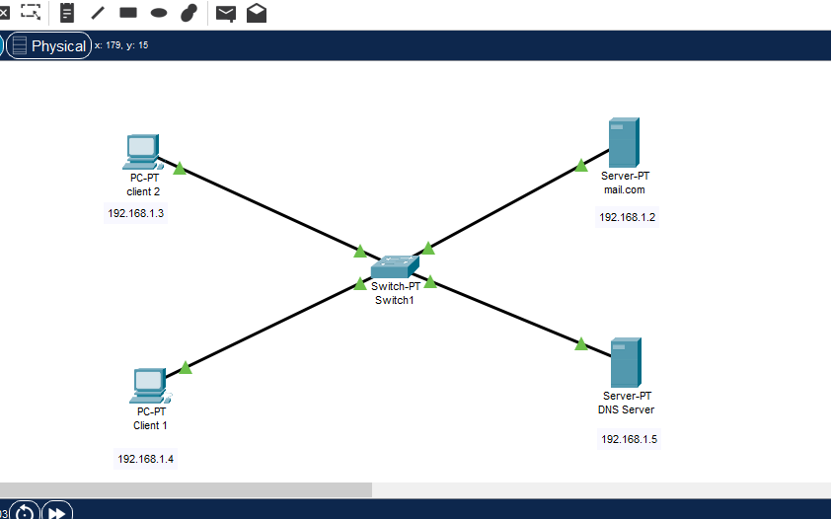

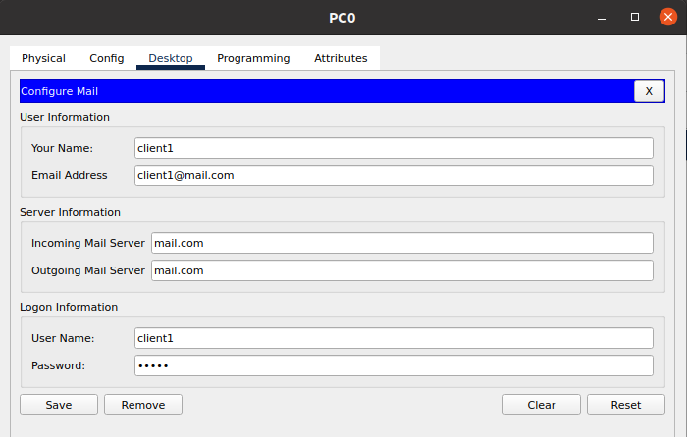

PC1:

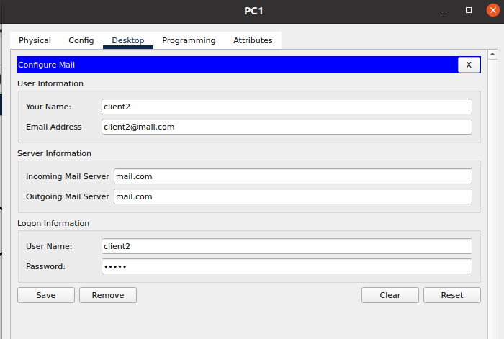

**Mail Server:**

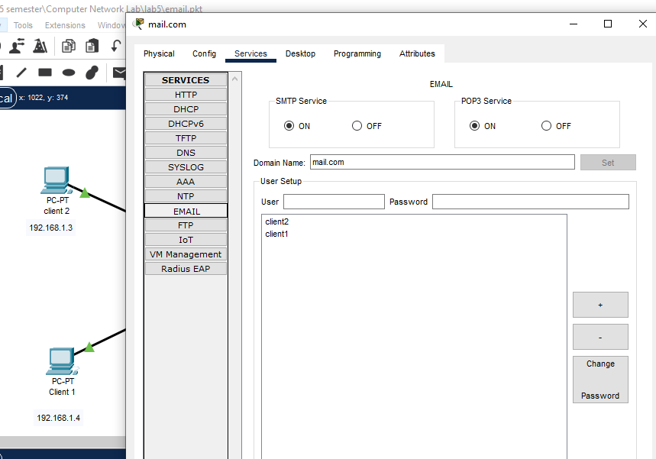

**DNS configuration**

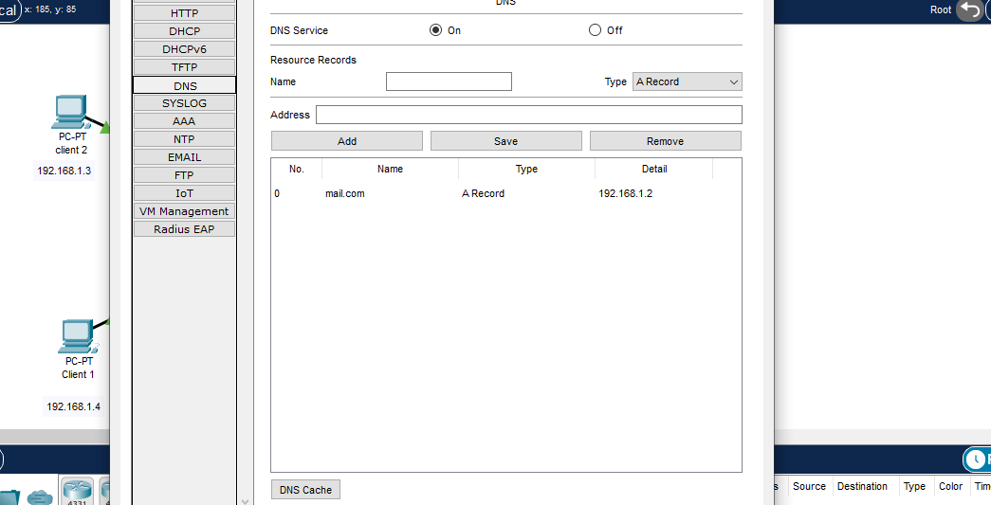

**Email service**

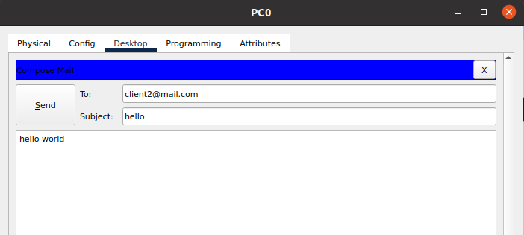

Receiver

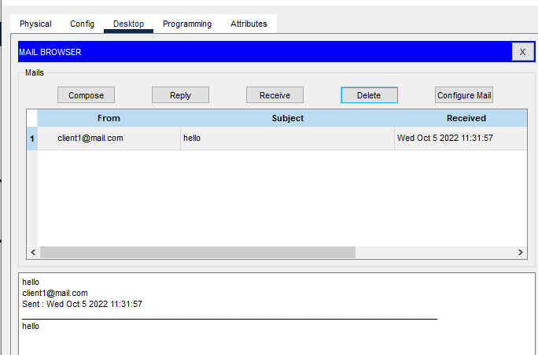

**Task 2**

**Create topology.**

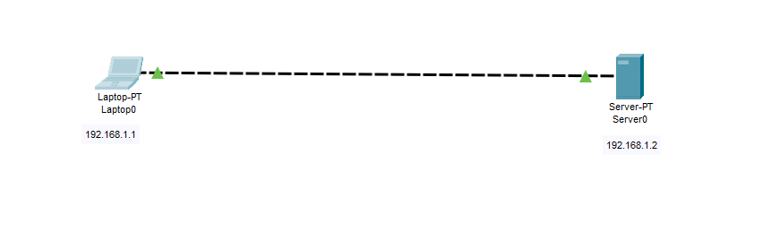

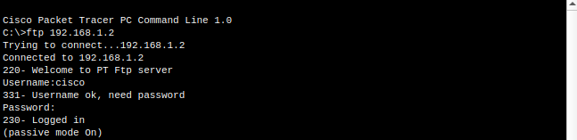

**Creating a file :**

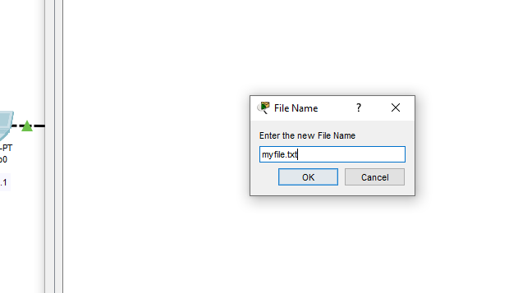

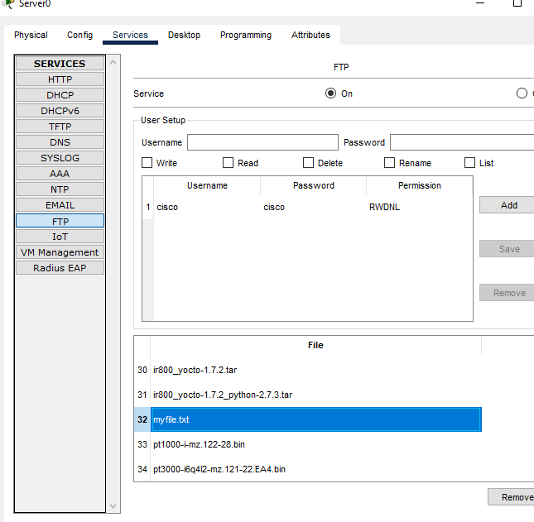

**Now upload the file from the Laptop**

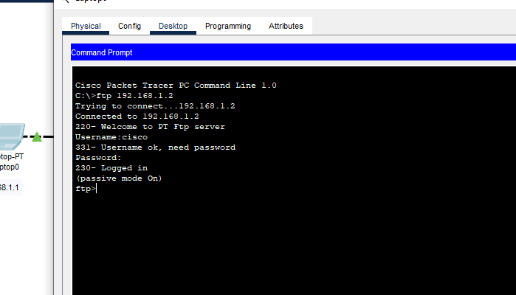

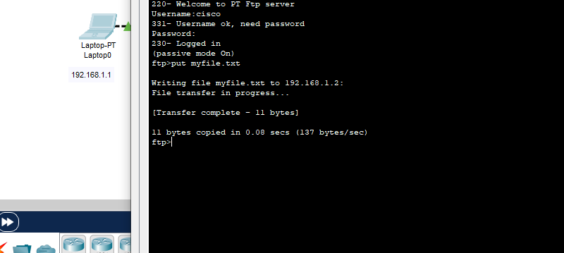

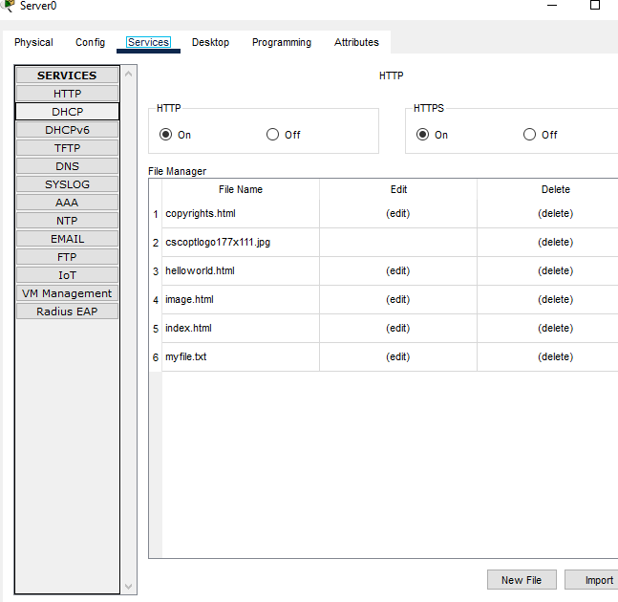

**Task 3: Create and Upload html file to HTTP server directory Using FTP**

**creating the following topology**

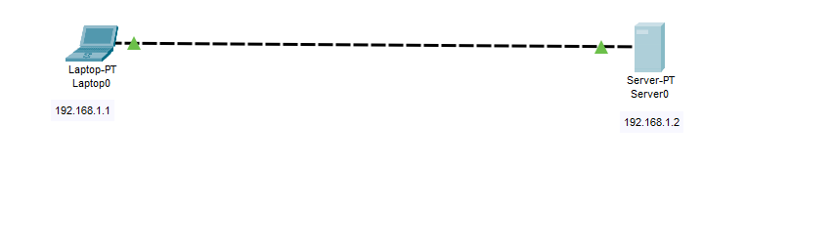

**Create an html file**

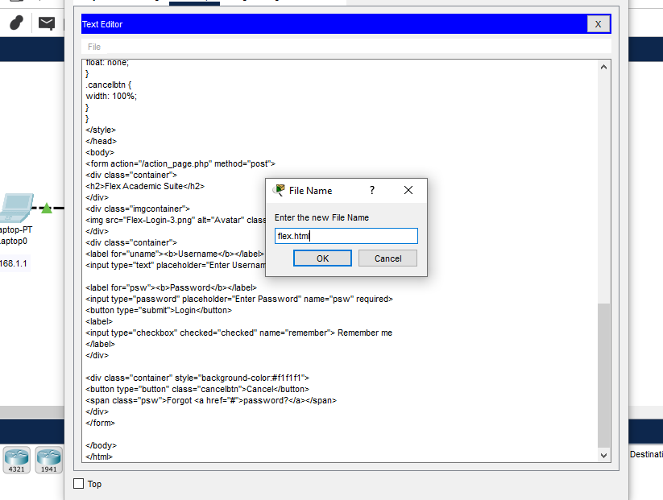

**Upload the html file onto the HTTP directory.**

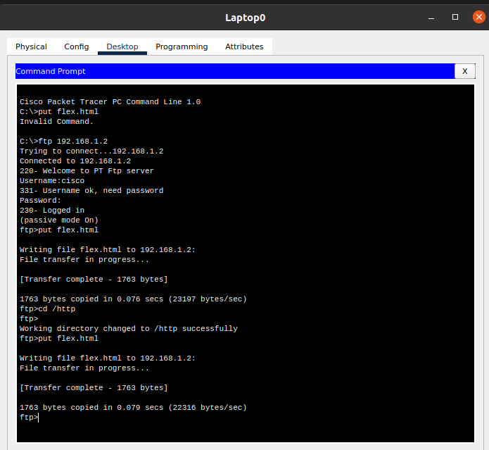

**Check whether the html file uploaded has been received in the HTTP directory:**

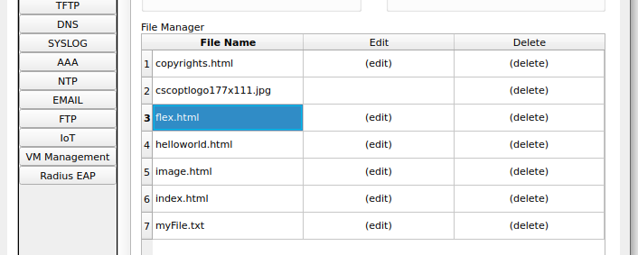

**Edit html file in the HTTP directory**

Now edit index.html file in the HTTP directory so as to include a link to flex that we’ve just uploaded.

This will make flex accessible from the Laptop’s browser. To do this, locate index.html then click edit.

Proceed to edit it as shown below. Then save and accept overwrite.

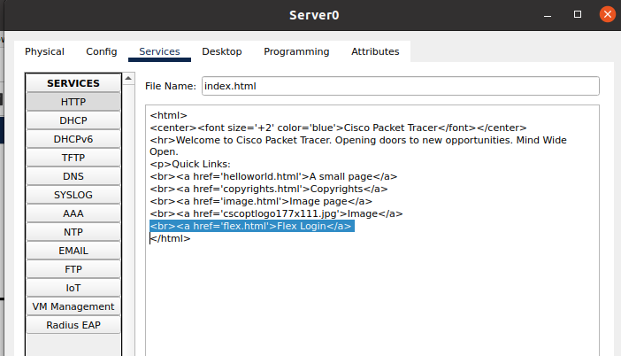

**Finally, try to access the newly uploaded file from the Laptop’s browser.**

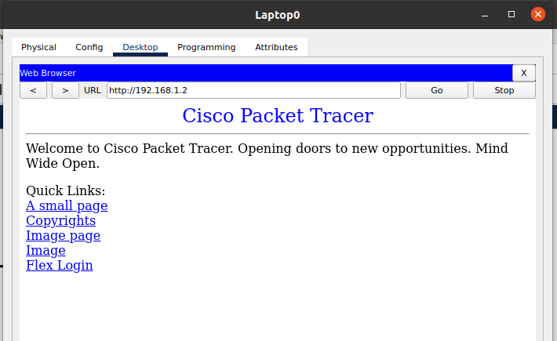

Click flex link to view the contents of the file in the browser.

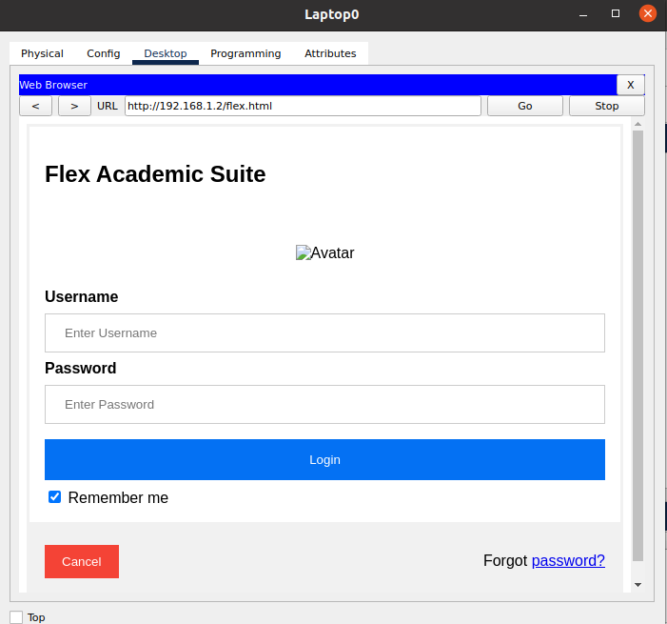

4. Configure Mail server, Ftp Server, DHCP Server, DNS Server and web Server in a single topology, use router and switch.

1. **Build the following topology**

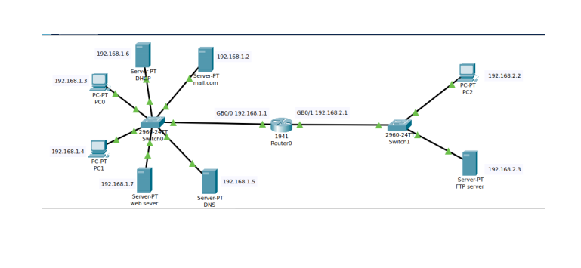

1. **Configure IP addresses on the PCs, DNS Server, DHCP server,Web server,FTP server and the Mail Server**

• Mail Server IP address: 192.168.1.2

• PC0 IP address: 192.168.1.4

• PC1 IP address: 192.168.1.3

• DNS server IP address: 192.168.1.5

• DHCP serverr IP address: 192.168.1.6

• Web serverr IP address: 192.168.1.7

• Router GigabitEthernet0/0 IP address: 192.168.1.1

• Router GigabitEthernet0/1 IP address: 192.168.2.1

• PC2 IP address: 192.168.2.2(dynamic through DHCP pool)

.) **FTP serverr IP address: 192.168.2.3 (through pool DHCP)**

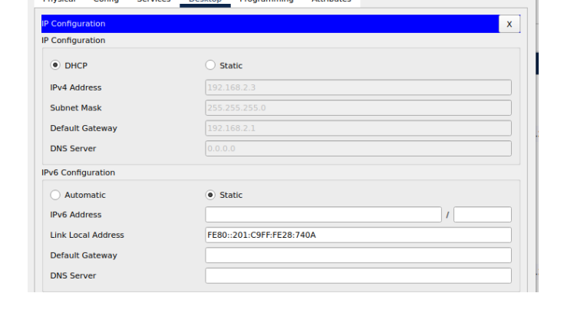

1. **Do the Following for router configuration**

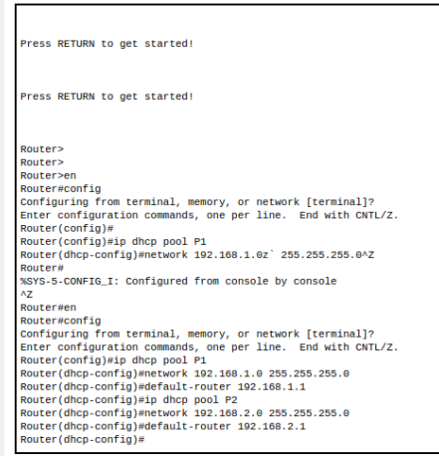

**4 . Create a file in the PC2 then upload it to the server using FTP**

**DONE ABOVE**

1. **) Now upload the file from the PC2 to the server using FTP**

**DONE ABOVE**

**6. . Go to the Server FTP directory to verify if the file sent has been received**

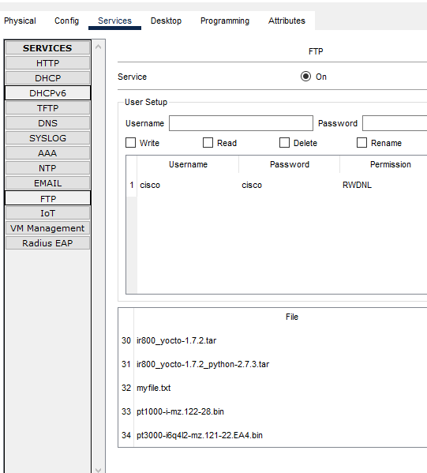

**7. Configure mail clients on the PCs and mail service on the generic server. Mail Clients:**

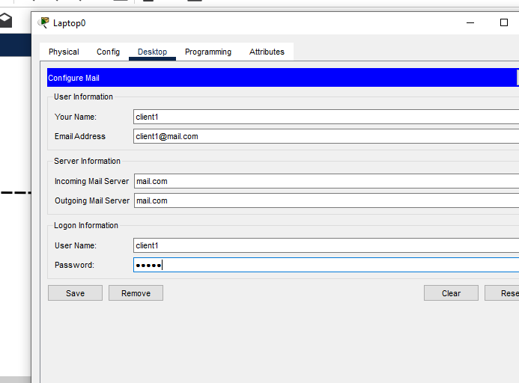

**8. Mail Server:**



9. **DNS configuration**

